Chapter 6
Testing
6.1: Correctness proving is the use of mathematical proof techniques to show that the product satisfies its specifications.

Verification is used in two ways, namely (a) non-execution-based testing, and (b) the process of determining that a specific activity has been completed correctly.

Validation is the process of determining whether the product as a whole satisfies its requirements.

6.2: If the organization is restructured so that 25 professionals, including five managers, are concerned solely with SQA, increased productivity and product quality can be expected. The costs to the company will include reorganization time (two day’s labor, approximately 75 × $875 + 19 × $1,175, or about $88,000) and training time and costs for the five SQA managers (perhaps $75,000). The total cost of about $180,000 should be recouped in a year even if productivity increases by only 3%.

6.3: Suppose that product development is done by five professionals including one manager, while SQA is done by the other two professionals including the other manager. Reorganization costs are now about $6,7500 (that is, less than one tenth of the costs for Problem 6.2), and training costs for only one manager are about $15,000. Again the total cost should soon be recouped.

6.4: Assuming that good testing techniques have been used, it is unlikely that there are any further faults.

6.5: Both are review processes performed by teams with the aim of finding faults. In both cases the material is studied by individual team members, and then the material is reviewed by the team as a group.

The major differences are: an inspection is a formal five-step process while a walkthrough has two informal steps; previously acquired fault statistics play an important role in the inspection process; there is a formal component of the inspection process for ensuring that all faults noted are later corrected; if more than a certain fraction of the material is changed then it must be submitted for reinspection.

6.6: The results of the experiments cited in Section 6.2.3 show that inspections both detect faults and save money.

6.7: Utility: Is it easy to use? How much training is needed for the package to be used effectively? How easy is the documentation to understand? Is the product reasonably priced compared to similar products on the market? Does it have all the features that we need?

Reliability: How frequently does the product fail? What are the results of such a failure, and how easy is it to resume work?

Robustness: How does the product react to invalid input data? What happens if the machine is turned off while data is in the course of being entered? What happens if the user bangs on the keyboard in the middle of a computation?

Performance: Can the product keep up with our fastest clerks? Can it handle our largest documents? What printers does it support? If it can handle spooling, how many documents can it spool at once? What are its networking capabilities? What is its response time under peak load?

Correctness: Does it function correctly? Are the commands correctly described in the user manual? Does it corrupt files in any way?

6.8: Utility: Is it easy to use? What types of encryption are supported? Can it transfer data between different types of hardware? Is it economically priced compared to similar products on the market?

Reliability: How accurate is the transmission of both large and small files?

Robustness: What happens if a single node or a combination of nodes goes down? How tolerant of line noise and spikes on the line is the product?

Performance: What speeds of data transfer are supported? How does performance degrade under increased load? Does the product degrade gracefully without loss of reliability? How secure is the network? What is the largest file and the smallest file that may be transferred?

Correctness: Does the product transfer files as laid down in the specifications?

6.9: Utility: Is it easy to use? What training is needed before using it? Is the training manual easy to follow?

Reliability: If aimed correctly, does it strike the target every time? Does it explode in flight?

Robustness: What happens if the missile is dropped? How does it function under battle conditions?

Performance: How accurate is the missile? Is its explosive power adequate to destroy any ship? Will a near-miss disable a ship, and if so, under what conditions? How much time elapses between the sighting of a target and the missile being launched? Can it cope with evasive action on the part of the target ship?

Correctness: Does the product function as laid down in its specifications?

6.10: The program cannot be proved correct, because there is no way of proving the k = n part of the output specification. Thus if the clause k ≤ n is dropped from the output specification, termination cannot be proved.

6.11: Because loop invariant (6.4) is true, k ≤ n. To exit from the loop, condition k ≥ n must hold. Thus when the loop terminates, k = n. Substituting this value for k in (6.4) yields output specification (6.3).

6.12: An annotated flowchart is shown in Figure 6.1.

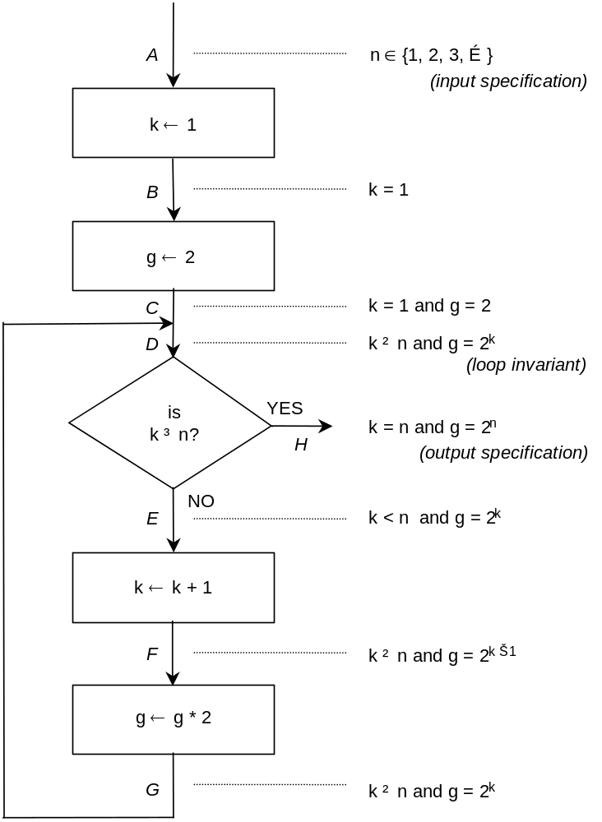

Figure 6.1. Annotated flowchart of code fragment of Problem 6.12.

An annotated flowchart is shown in Figure 5.1.

The input specification is A: n ∈ {1, 2, 3, …}. It clearly holds at all points on the flowchart, and is omitted for simplicity. The assertions at B and C follow trivially.

The loop invariant D: k ≤ n and g = 2^{k} holds the first time the loop is entered, because k = 1 and 2¹ = 2. Assume that it holds at D for some k = k₀. Then, if k₀ ≥ n the loop terminates, and the output condition is satisfied at H. If not, control passes to E; as a result of the failed conditional, k₀ < n. Also, g = 2 by hypothesis.

At F, the value of k₀ has been increased by 1, and thus k₀ ≤ n and g = 2^{k0 – 1} as indicated on the flowchart. At G, g has been multiplied by 2. The assertion at G follows from the fact that 2 × 2^{k0 – 1} = 2^{k0}.

The assertion at point G is identical to the assertion which, by hypothesis, holds at point D. But point D is topologically identical to point G. By induction it follows that the loop invariant holds for all values of k, 1 ≤ k ≤ n.

All that remains is to prove that the loop terminates. Initially the value of k is equal to 0. Each time the loop is iterated the value of k is increased by 1 by the statement k ← k + 1. As a consequence of the loop invariant, k cannot exceed n. Eventually k must therefore reach the value n, at which time the loop is exited, and the value of g satisfies the output specification, that is, g = 2^{n}.

6.13: A correctness proof is merely a mathematical demonstration that a product satisfies its specifications. The specifications may or may not reflect the client’s real needs. There is no connection between the client’s needs and correctness proving.

6.14: “Correctness proving can be a very effective way to show both the presence and absence of bugs, when used in conjunction with execution-based testing.”

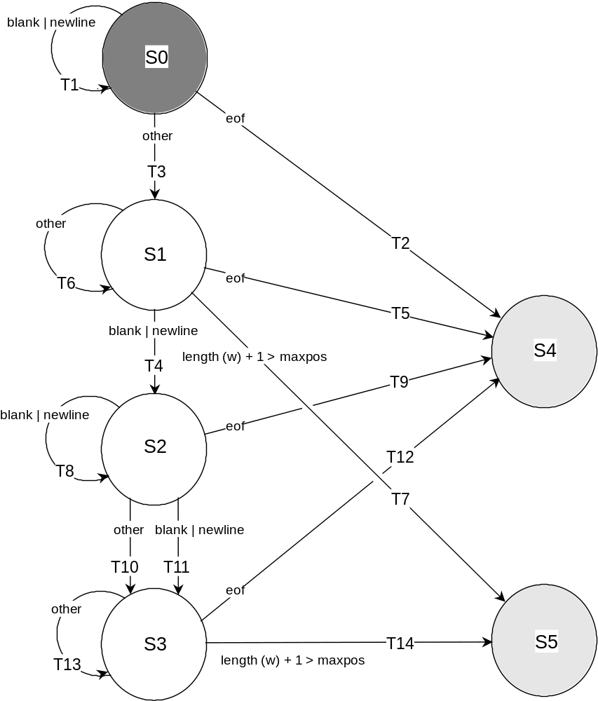
Figure 6.2. Extended FSM for Naur’s text processing problem.

6.15: A design using an extended finite state machine (Section 11.6) is given in Figure 6.2.
States
S0 Starting state—“Waiting for first character of first word of file”
S1 “Building the first word”
S2 “Waiting for first character of another word”
S3 “Building another word”
S4 Final State—“End-of-file condition”
S5 Final State—“Word longer than MAXPOS characters encountered”

Inputs
NEWLINE New line character
BLANK Blank character
EOF End of file condition when read attempted
other All other characters

Initial Conditions
Variable line_length, integer, number of characters in current output line. Initially 0.
Variable word, character string, word currently being built. Initially empty.
Variable c, current input character. No initial value.
Constant MAXPOS, maximum characters in output line, excluding NEWLINE.

Transitions and Associated Actions
T1 Waiting for first word and BLANK or NEWLINE is input
T2 Waiting for first word and EOF is reached
T3 Waiting for first word and other character is input
word ← c
T4 Building first word and BLANK or NEWLINE is input
write (word)
line_length ← length (word)
word ← null
T5 Building first word and EOF is reached
T6 Building first word and other character is input
word ← word ∪ c (concatenate word word and character c)
T7 Building first word and its length will be > MAXPOS
T8 Waiting for another word and BLANK or NEWLINE is input
T9 Waiting for another word and EOF is reached
T10 Waiting for another word and other character is input
word ← word ∪ c
T11 Building another word and BLANK or NEWLINE is input
if line_length + 1 + length (word) > MAXPOS
{
write (NEWLINE, word)
line_length ← length (word)
}
else
{
write (BLANK, word)
line_length ← line_length + 1 + length (word)
}
word ← null
T12 Building another word and EOF reached
if line_length + 1 + length (word) > MAXPOS
write (NEWLINE, word)
else
write (BLANK, word)
T13 Building another word and other character input
word ← word ∪ c
T14 Building another word and its length will be > MAXPOS

C Code
#include <stdio.h>
#include <string.h>

#define BLANK ' '
#define NEWLINE '\n'
#define MAXPOS 10

struct word_type
{
char word_arr[80];
int length;
} word_type;

FILE *fp;

char get_character (void)
{
char character_read;

character_read = getc (fp);
if (character_read == EOF)
return (EOF);
else if (character_read == NEWLINE)
return (BLANK);
else
return (character_read);
}

void main (void)
{
char current_char; /* current character being processed */
int line_length = 0; /* length of current output line */
int state = 0; /* current state of finite state machine */
struct word_type *word; /* current word being built */
char tmp[1];
int i;

fp = fopen ("data", "r");

word = (struct word_type *) malloc (sizeof (struct word_type));
strcpy (word->word_arr, ""); /* initially word is empty */
word->length = 0;

while (state < 4)
{
current_char = get_character ();
switch (state)
{
case 0:
{
switch (current_char)
{
case BLANK: /* T1 */
break;

case EOF: /* T2 */
{
state = 4; /* this terminates loop */
break;
}

default: /* T3 */
{
word->word_arr[0] = current_char;
word->length = 1;
state = 1;
break;
}
} /* switch (current_char): case 0 */
break;
} /* switch (state): case 0 */

case 1:
{
switch (current_char)
{
case BLANK: /* T4 */
{
printf ("%s", word->word_arr);
strcpy (word->word_arr, "");
line_length = word->length;
word->length = 0;
state = 2;
break;
}

case EOF: /* T5 */
{
printf ("%s", word->word_arr);
state = 4; /* this terminates loop */
break;
}

default: /* T6 */
{
if (word->length + 1 > MAXPOS) /* T7 */
state = 5; /* this terminates loop */
else
{
tmp[0] = current_char;
strncat (word->word_arr, tmp, 1);
}
break;
}
} /* switch (current_char): case 1 */
break;
} /* switch (state): case 1 */

case 2:
{
switch (current_char)
{
case BLANK : /* T8 */
break;

case EOF: /* T9 */
{
state = 4; /* this terminates loop */
break;
}

default: /* T10 */
{
tmp[0] = current_char;
strncat (word->word_arr, tmp, 1);
state = 3;
break;
}
} /* switch (current_char): case 2 */
break;
} /* switch (state): case 2 */

case 3:
{
switch (current_char)
{
case BLANK: /* T11 */
{
if ((line_length + 1 + word->length) > MAXPOS)
{
printf ("\n");
printf ("%s", word->word_arr);
line_length = word->length;
}
else
{
printf ("%c", BLANK);
printf ("%s", word->word_arr);
strcpy (word->word_arr, "");
line_length = line_length + 1 + word->length;
}
word->length = 0;
state = 2;
break;
}

case EOF: /* T12 */
{
if ((line_length + 1 + word->length) > MAXPOS)
{
printf ("\n");
printf ("%s", word->word_arr);
line_length = word->length;
}
else
{
printf ("%c", BLANK);
printf ("%s", word->word_arr);
line_length = line_length + 1 + word->length;
}
state = 4; /* this terminates loop */
break;
}

default: /* T13 */
{
if ((word->length + 1) > MAXPOS) /* T14 */
state = 5; /* this terminates loop */
else
{
tmp[0] = current_char;
strncat (word->word_arr, tmp, 1);
}
break;
}
} /* switch (current_char): case 3 */
break;
} /* switch (state): case 3 */

default:
break;
} /* switch (state): default */
} /* while (state < 4) */

printf ("\n");
if (state == 5)
printf ("Word longer than permitted length encountered\n");

free (word);
} /* main */

A flowchart for the product is given in Figure 6.3.

get_character / getCharacter

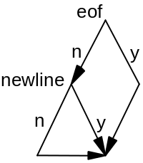
main / NaurApp

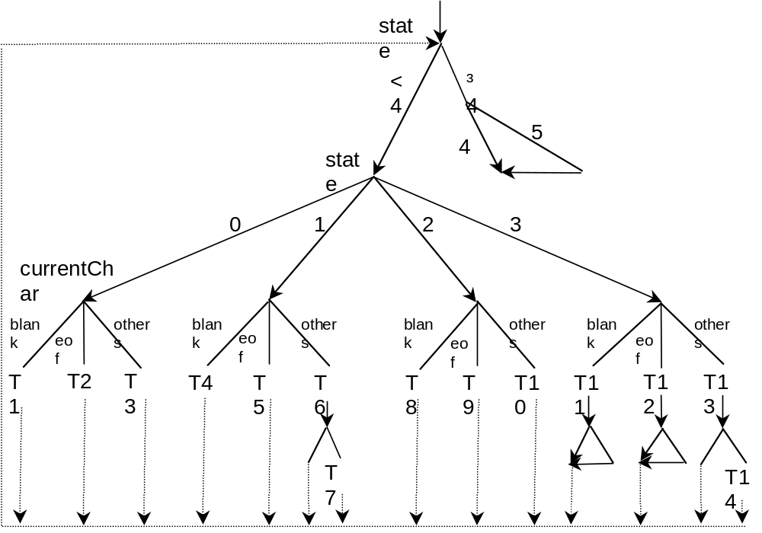

Figure 6.3. Flowchart of implementation of Naur’s text processing problem.

JAVA Code
import java.io.*;
import java.util.*;

class NaurTextProcessing
{
private final int MAXPOS = 10;
private boolean debugOn = false;

public void turnDebugOn () { debugOn = true; }
public void turnDebugOff () { debugOn = false; }

private char getCharacter (RandomAccessFile inFile)
{
//
// If we are not at end of inFile then read in next character.
// If we are at end of file return an empty character. If
// character read is a newline then return a blank. Otherwise,
// return character that was read from the file.
//

try
{
char characterRead;

if (inFile.getFilePointer () == inFile.length ())
characterRead = '\0';
else
characterRead = (char) inFile.readByte ();

if (characterRead == '\n')
characterRead = ' ';

return (characterRead);

}
catch (Exception e)
{
System.out.println ("***** Error in NaurApp.getCharacter () *****");
System.out.println ("\t" + e);
return '\0';
}

} // getCharacter ()

public void runApp ()
{

try
{
char currentChar; // current character being processed
int lineLength = 0; // length of current output line
char state = '0'; // current state of finite state machine
StringBuffer word = new StringBuffer (); // current word being built
char tmp;
int i;

File inputFile = new File ("naur.dat");

if (!inputFile.exists ())
{
System.out.println ("Input file 'naur.dat' does not exist.");
return;
}

RandomAccessFile inFile = new RandomAccessFile (inputFile, "r");

//
// Character.digit (state, 10) returns integer value corresponding to
// character state. Computation is performed in base-10 arithmetic.
//
while (Character.digit (state, 10) < 4)
{
currentChar = getCharacter (inFile);

if (debugOn)
{
System.out.print ("State: " + state + "\t");

switch (currentChar)
{
case '\0':
System.out.println ("End of file.");
break;
case ' ':
System.out.println ("Blank/Carriage Return.");
break;
default:
System.out.println ("Character read: " + currentChar + ".");
}
} // if

switch (state)
{
case '0':
if (debugOn)
System.out.println ("Entering state 0.");

switch (currentChar)
{
case ' ': // character is a blank or a newline
break; // T1
state = '4';

case '\0': // end of file was reached state = '4'; // this terminates loop
break; // T2

default: // T3
word.append (currentChar);
state = '1';
break;
} // switch (currentChar)
break;

case '1':
if (debugOn)
System.out.println ("Entering state 1");

switch (currentChar)
{
case ' ': // character is a blank or a newline
System.out.print (word.toString ()); // T4
lineLength = word.length ();
word = new StringBuffer ();
state = '2';
break;

case '\0': // end of file was reached
System.out.println (word.toString ()); // T5
state = '4'; // this terminates loop
break;

default:
if (word.length () <= MAXPOS) // T6
word.append (currentChar);
else
state = '5'; // this terminates loop
break; // T7
} // switch (currentChar)
break;

case '2':
if (debugOn)
System.out.println ("Entering state 2");

switch (currentChar) {
case ' ': // character is a blank or a newline
break; // T8

case '\0': // end of file was reached
state = '4'; // this terminates loop
break; // T9

default: // T10
word.append (currentChar);
state = '3';
break;
} // switch (currentChar)
break;

case '3':
if (debugOn)
System.out.println ("Entering state 3");

switch (currentChar)
{
case ' ':
case '\0':
if ((lineLength + word.length ()) <= MAXPOS)
{
System.out.print (currentChar);
System.out.print (word.toString ());
lineLength = lineLength + 1 + word.length ();
word = new StringBuffer ();
}
else
{
System.out.println ();
System.out.print (word.toString ());
lineLength = word.length ();
word = new StringBuffer ();
}

if (currentChar != '\0')
state = '2'; // T11
else
state = '4'; // this terminates loop // T12
break;

default: // T13
if ((word.length ()) <= MAXPOS) // T14
word.append (currentChar);
else
state = '5'; // this terminates loop
break;
} // switch (currentChar)
break;

default:
break;
} // switch (state)
} // while (Character.digit (state, 10) < 4)

System.out.println ();
if (state == '5')
System.out.println ("Word longer than permitted length encountered");

inFile.close ();

}
catch (Exception e)
{
System.out.println ("***** Error in NaurApp.main () *****");
System.out.println ("\t" + e);
}

} // runApp ()

} // class NaurTextProcessing

class NaurApp
{
public static void main (String args[])
{
NaurTextProcessing naur = new NaurTextProcessing ();

if (args[0] == "true")
naur.turnDebugOn ();

naur.runApp ();
}
} // class NaurApp

